**Lab 2**

**Question 1:**

* Perform all arithmetic operations using assignment operators for current semester courses. Addition between three courses. Total marks of current semester.
* With the help of arithmetic operations describe which number is even and odd form following: **101, 500, 204.**

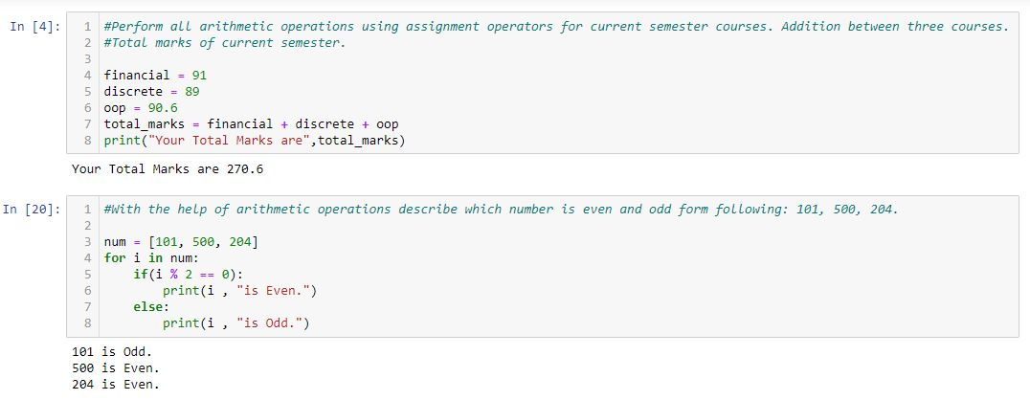

**Question 2:**

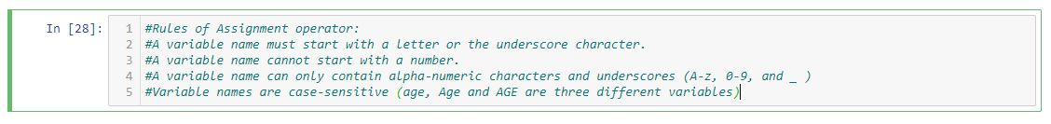Define Rules of Assignment operators.

**Question 3:**

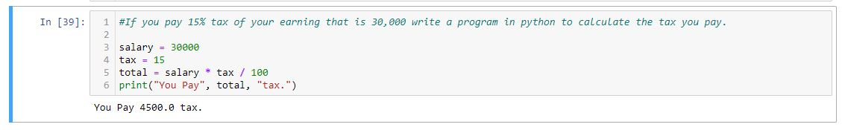If you pay 15% tax of your earning that is 30,000 write a program in python to calculate the tax you pay.

**Question 4:**

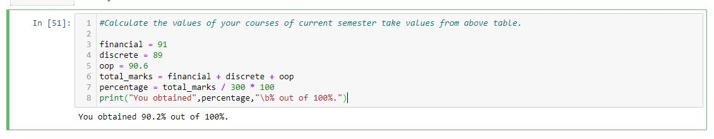Calculate the values of your courses of current semester take values from above table.

**Question 5:**

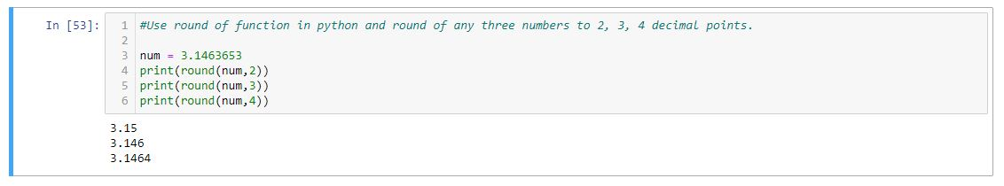Use round of function in python and round of any three numbers to 2, 3, 4 decimal points.

**Question 6:**

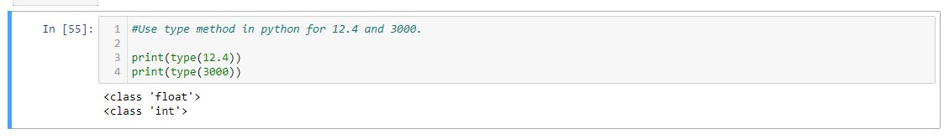Use type method in python for 12.4 and 3000.

**Question 7:**

Convert 6.0 to 6.

